**RV College of Engineering®**

**(Autonomous Institution Affiliated to VTU, Belgaum)**

**Department of Electronics and Instrumentation Engineering**



**V Semester**

(2019-20)

ODD Semester

**Self-Study Report**

**Topic: “Brain Tumor Detection from MRI using Image Processing“**

**Under the guidance of:**

**Dr. K. B. Ramesh**

**Dr. Sandesh R. S.**

**Group Members USN Signature**

**1. Aisiri H R 1RV17EI004**

**2. S J Ruthvik 1RV17EI044**

**3. Srinivas Prabhu B 1RV17EI056**

**4. Vinay Balamurali 1RV17EI063**

Submitted to

**Department of Electronics and Instrumentation Engineering**

**RV College of Engineering®, Bengaluru – 560059**

**(Autonomous Institution Affiliated to VTU, Belgaum)**



**CERTIFICATE**

Certified that the Self Study work titled **‘Brain Tumor Detection from MRI using Image Processing’** was carried out by **Aisiri HR, Ruthvik SJ, Srinivas Prabhu B, Vinay Balamurali** who are bonafide Students of R.V. College of Engineering, Bengaluru in partial fulfillment for the award of degree in **Bachelor of Engineering** for **Electronics and Instrumentation Engineering** of the Visvesvaraya Technological University, Belgaum during the year **2019-2020.** It is certified that all corrections/suggestions indicated for the internal assessment have been incorporated in the report deposited in the departmental library. The Self Study report has been approved as it satisfies the academic requirements in respect of Self Study work prescribed by the institution for the said degree.

Marks awarded = (Phase 1 + Phase 2) =

**Signature of Faculty In-charge:**

**Signature of Head of the Department**

(Dr. C.H.Renumadhavi)

1. Dr. KB Ramesh

2. Dr.Sandesh R.S

**Table of Contents**

**INTRODUCTION**3

**MOTIVATION**3

**LITERATURE SURVEY**4

**AIM**4

**OBJECTIVES**4

**BLOCK DIAGRAM**4

**METHODOLOGY**5

**SOFTWARE REQUIREMENTS**5

**APPLICATIONS**5

**RESULTS AND CONCLUSION**6

**COURSE MAPPING**7

**COURSE OUTCOME**7

**REFERENCES**8

# INTRODUCTION:

* Brain Tumor is a fatal disease that cannot be confidently detected without MRI. Brain tumors are basically cancerous (malignant) or non-cancerous (benign) mass or growth of abnormal cells in the brain. Causes of brain tumor include exposure to vinyl chloride, Epstein–Barr virus, ionizing radiation, and inherited syndromes such as neurofibromatosis, tuberous sclerosis, and von Hippel-Lindau Disease
* [Medical imaging](https://en.wikipedia.org/wiki/Medical_imaging) plays a central role in the diagnosis of brain tumors using either Computed Tomography (CT) or Magnetic Resonance Imaging (MRI).
* An MRI is a type of scan that creates pictures using magnetism and radio waves. MRI scans produce pictures from angles all around the body and show up soft tissues very clearly. MRI can be used to measure the tumor size. A special dye called a contrast medium is given before the scan to create a clearer picture
* MRI’s are preferred to CT scans as they produce more detailed images of the soft tissues.
* This project is used to detect brain tumor from an MRI image using MATLAB simulation
* This simulation routine is not completely foolproof. It fails to provide an accurate result when the tumor size is either too small or too hollow

# MOTIVATION:

* The motivation for doing this project was primarily an interest in undertaking a challenging project in an interesting area of research. The opportunity to learn about a new area of computing not covered in lectures was appealing.
* Another motivation was to increase the percentage of correctly detecting brain tumors and to use machine learning algorithms in the future by feeding the machine with tens of thousands of MRI images to beat the accuracy gotten by human analyses

# LITERATURE SURVEY:

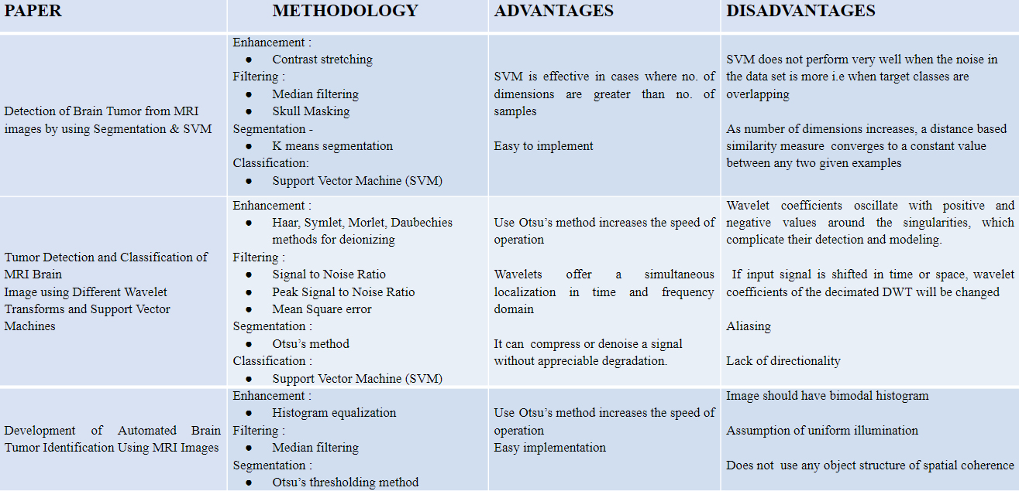

# AIM:

1. Prototype development of Brain Tumor
2. Detection from MRI using Image Processing.

# OBJECTIVES:

1. To detect if there is a tumor in a given MRI Image.
2. If there is, specify the location of the tumor

# 

# BLOCK DIAGRAM:

# 

# METHODOLOGY:

1. Anisotropic Diffusion Filter is first applied to reduce the contrast between consecutive pixels while preserving the edges and boundaries.
2. This image is then resized and thresholded for a Black and White image.
3. Morphological operation is then performed on this pre-processed image. This provides us with the tumor location.
4. The obtained tumor is then eroded and then subtracted from the tumor image to get the tumor outline.
5. This tumor outline is then drawn onto the test image for tumor detection if any.

# 

# SOFTWARE REQUIREMENTS:

1. MATLAB Software
2. Image Processing Tool Box

# APPLICATIONS:

1. MRI imaging is less harmful than an X-ray. It is less attenuated by bones.
2. MRI provides high spatial resolution and excellent soft tissue diagnosis.
3. This project can make MRI image processing and tumor detection process faster and cheaper.
4. Early and accurate detection followed by treatment can save a life.
5. Telemedicine applications.
6. Manual identification is neither fast nor accurate nor efficient, this application is designed to overcome this problem.
7. Accurate detection of secondary tumors,

# RESULTS AND CONCLUSION:

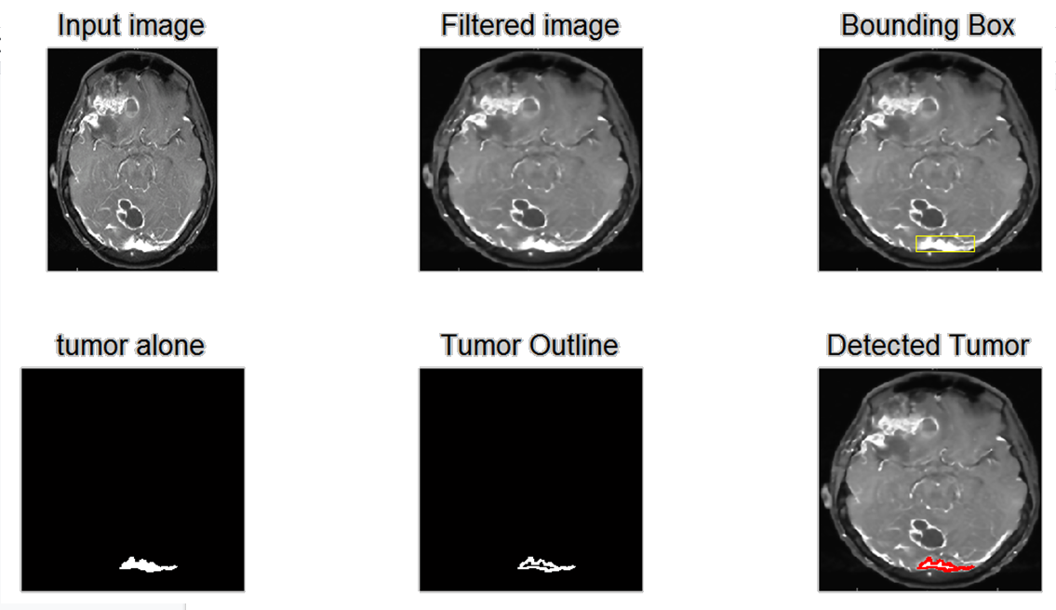

* May give false positive if the section of bones is too thick.
* May give false negative if the tumor image is hollow, i.e. density of tumor is low.

# COURSE MAPPING:

|  |  |
| --- | --- |
| **COURSE** | **RELEVANCE** |
| DSP | * Digital Image Processing is one of the most important applications of Digital Signal Processing. * Understanding and application of filter concepts |
| BIOMEDICAL INSTRUMENTATION | * Medical image processing continues to enable biomedical instrumentation revolution that we are experiencing today * NMR imaging technique as superior to other imaging techniques in Biomedical was studied and incorporated in the project. |

# COURSE OUTCOME:

|  |  |  |  |  |
| --- | --- | --- | --- | --- |
| **COURSE** | **CO1** | **CO2** | **CO3** | **CO4** |
| DSP |  |  |  |  |
| BIOMEDICAL INSTRUMETATION |  |  |  |  |

# 

# 

# 

# 

# 

# REFERENCES:

1. M.H. Fazel Zarandia, M. Zarinbala, M.Izadib (2011), “Systematic image processing for diagnosing brain tumors: A Type-II fuzzy expert system approach," *Applied soft computing 11,* 285-294.
2. Mircea Gurbin, Mihaela Lascu, and Dan Lascu, “Tumor Detection and Classification of MRI Brain Image using Different Wavelet Transforms and Support Vector Machines"
3. Swapnil R. Telrandhe, Amit Pimpalkar, and Ankita Kendhe, “Detection of Brain Tumor from MRI images by using Segmentation & SVM", *2016 World Conference on Futuristic Trends in Research and Innovation for Social Welfare (WCFTR’16).*
4. Pallavi M. Gavale, Priti V. Aher, Darshana V. Wani, Ashwini B. Kakade, “Medical Application For Brain Tumor Detection And Area Calculation Using Algorithm”. International Research Journal of Engineering and Technology (IRJET)
5. M. Usman Akram, Anam Usman,” Computer-Aided System for Brain Tumor Detection and Segmentation”
6. RS Khandpur, Handbook of Biomedical Instrumentation.